

Engineering Economics Course Project

Carbon Taxes to minimize cO2 emissions in a micro-grid

Prepared for ECON74000, Winter 2018

David Eelman (6365316)

Stanislav Rashevskyi (7028178)

Thomas Abdallah (7141518)

Contents

Introduction 2

Problem Statement 3

Assumptions 3

Economic Analysis 3

Levelized Cost of Energy (LCOE) 3

Present Worth Analysis 4

Incremental Internal Rate of Return Analysis 7

Equivalent Annual Cost Analysis 8

Factors Missing From Analysis 8

Appendix A – Present Worth Analysis Calculations 10

Appendix B – Incremental Internal Rate of Return Analysis Calculations 12

Bibliography 14

# Introduction

This report will identify the best energy production option and associated carbon tax price to incent the adoption of renewable energy sources and minimize the use of diesel fuel generation in a micro-grid application for a remote Northern Ontario community. The analysis will consider four energy production options (Table 1) that could be purchased and become operational in 2019. These options include a mix of wind, solar, and diesel energy production. The analysis for this project will consider the present worth, the incremental internal rate of return, and the equivalent annual cost for each energy production option. A tax (dollar per kilogram of CO2 emissions) will be proposed that shall minimize diesel fuel generation and increase the feasibility of the options that include renewable energy sources. The same analysis will be performed using the tax rules of the United Kingdom to provide comparison on the feasibility of the project in that country.

Table 1 - Generation Options



# Problem Statement

This report will determine an appropriate CO2 tax to be applied that will minimize the use of diesel fuel generation in a theoretical micro-grid application in Northern Ontario and compare the feasibility of this project to the same project if it were undertaken in the United Kingdom.

### Assumptions

1. Yearly maintenance cost increase is 5% of the previous year’s maintenance cost.
2. Yearly CO2 emissions increase is 2% of the previous year’s CO2 emissions.
3. Yearly diesel fuel cost increase is 2% of the previous year’s diesel fuel cost.
4. No tax credits or other government incentives for any generation option.
5. 100% utilization rate for all generation options, i.e. running at maximum power output 24 hours a day, 365 days a year.
6. Same cost of financing for all generation options.

# Economic Analysis

### Levelized Cost of Energy (LCOE)

The concept of LCOE represents the total cost per unit of energy of constructing and operating a power plant over its lifetime (U.S. Energy Information Administration, 2018). LCOE provides a convenient mechanism for comparing the competitiveness of different generation technologies. In this report we only consider the capital costs, fuel costs, and maintenance costs when evaluating each generation option, although a full LCOE analysis would include the cost of financing, operation, and utilization rates for each generation option.

### Present Worth Analysis

The present worth of each option from Table 1 was conducted utilizing the corporate tax rate in Canada of 36.1% (Pearson Canada, Inc., 2017), a before-tax MARR of 20%, and a Capital Cost Allowance (CCA) of 20% (Class 8). After-tax MARR is calculated to be 12.78% as shown below. option.

The Capital Tax Factor (CTF) is calculated as shown below.

The present worth of the capital cost for each generation option is calculated as follows.

Table 2 - Present worth of capital cost



The present worth for all annuities associated with each generation option are calculated as follows. Table 3 shows the present worth of all annuities over a 20 year period for each option. Appendix A shows the Excel calculations used to generate these values.

Table 3 - Present worth of annuities



The total present worth for each option is sum of the present worth of the annuities and the present worth of the capital cost. Table 4 shows the total present worth after taxes for each option with no carbon tax implemented.

Table 4 - Total Present Worth



The diesel only option is considerably more cost-effective than the others without the inclusion of a carbon tax. When applying a carbon tax the total present worth of each project decreases significantly. As shown in Figure 1 a carbon tax price of $0.09/kg-CO2 is the point where the total present Solar + Wind + Diesel option surpasses the total present value of the Diesel only option. Therefore based on the present worth analysis a carbon tax of $0.09/kg-CO2 is recommended to incent the adoption of renewables over diesel.

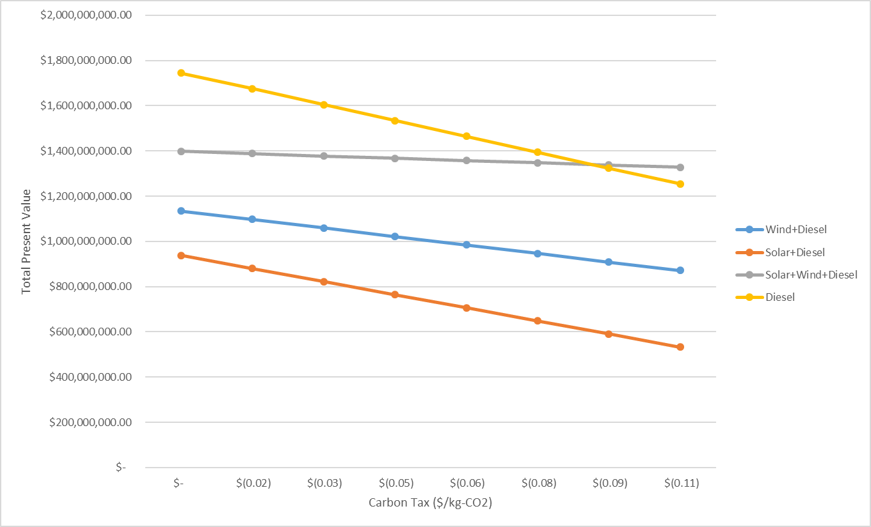

Figure 1 - Present Value vs Carbon Tax Rate

If we consider the same analysis conducted in the United Kingdom with a tax rate of 28% (after-tax MARR of 14.4%) and using straight-line depreciation to determine the tax savings on the capital investment we find that a carbon tax rate of approximately $0.075/kg-CO2 results in the present worth of the Solar + Wind project surpassing that of the Diesel only project (Figure 2). Therefore based on the present worth analysis a carbon tax of $0.075/kg-CO2 is required to incent the adoption of renewables over diesel in the UK.

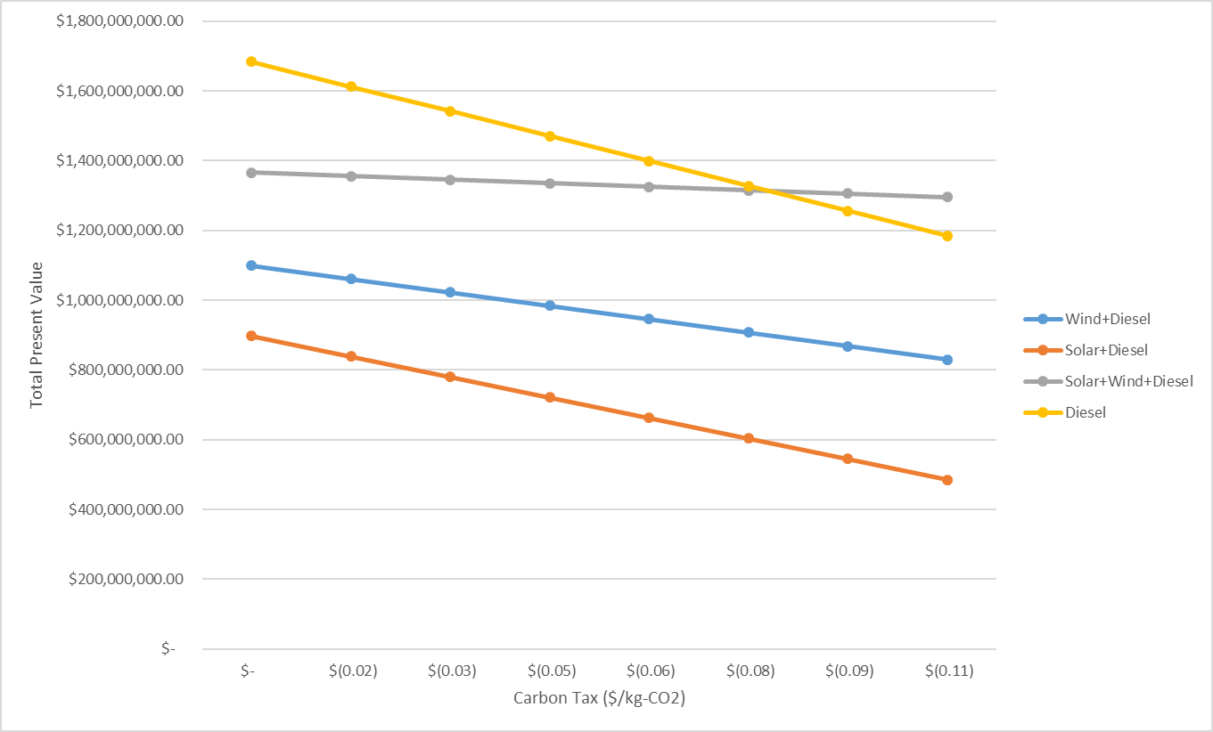

Figure 2 - Present Value versus Carbon Tax Rate in the United Kingdom

### Incremental Internal Rate of Return Analysis

Analysis begins by selecting the Diesel only project as it has the lowest initial capital cost. Incremental cash flows are calculated for the Wind + Diesel project as it has the next lowest initial capital cost. Internal rate of return for the incremental cash flow with no carbon tax is calculated -31% so the project should not be taken. Appendix B shows the after-tax incremental cash flows and IRR calculation from Excel. The incremental IRR equals after-tax MARR for a carbon tax rate of $79/kg-CO2, therefore we would recommend this carbon tax rate to incentivize the adoption of renewables based on the incremental rate of return analysis. With this carbon tax applied, we select the Wind + Diesel option over the Diesel only option by incremental IRR and move on to calculating the incremental IRR for the Solar + Wind + Diesel project as it has the next lowest capital cost. The incremental IRR for this project versus the Wind + Diesel project is 178.14% (Appendix B), so this project is selected. The incremental cash flows for the Solar + Diesel project versus the Solar + Wind + Diesel project are all negative so no valid IRR can be calculated and the project is rejected. Therefore, based on the incremental rate of return method the Solar + Wind + Diesel project would be selected with a recommended carbon tax rate of $79/kg-CO2.

If we consider the same analysis conducted in the United Kingdom with a tax rate of 28% (after-tax MARR of 14.4%) and using straight-line depreciation to determine the tax savings on the capital investment we find that a carbon tax rate of approximately $100/kg-CO2 results in an incremental IRR of 14.48% for the Diesel + Wind project when compared to the Diesel only project, thus the Diesel + Wind project should be selected over the Diesel only project. The incremental IRR for the Diesel + Wind + Solar project versus the Diesel + Wind project is 196% so it should be selected over the Diesel + Wind project. The incremental cash flows for the Solar + Diesel project versus the Diesel + Wind + Solar project are all negative so no valid IRR can be calculated and the project is rejected. Therefore, based on the incremental rate of return method the Solar + Wind + Diesel project would be selected with a recommended carbon tax rate of $100/kg-CO2 if this project was considered in the UK.

### Equivalent Annual Cost Analysis

### Factors Missing From Analysis

This analysis does not consider any government incentives for renewable projects such as tax credits for renewable projects or discounted financing options which could help to reduce the cost of the proposed carbon tax. This analysis only considers the maintenance and fuel costs for each plant type but does not account for any other operating costs which may impact the total cost of each plant. This analysis only considers carbon produced during the operation of each plant type and does not account for the carbon produced when manufacturing the plant.

# Appendix A – Present Worth Analysis Calculations



Figure 3 - Present worth of annuities, Wind + Diesel Option



Figure 4 - Present worth of annuities, Solar + Diesel Option



Figure 5 - Present worth of annuities, Solar + Wind + Diesel Option



Figure 6 - Present worth of annuities, Diesel Option

# Appendix B – Incremental Internal Rate of Return Analysis Calculations

|  |  |
| --- | --- |
| Figure 7 - Incremental IRR for Wind + Diesel vs. Diesel, No Carbon Tax | Figure 8 - Incremental IRR for Wind + Diesel vs. Diesel, Carbon Tax of $79/kg-CO2 |
| Figure 9 - Incremental IRR for Wind + Solar + Diesel vs. Wind + Diesel, Carbon Tax of $79/kg-CO2 |  |

# Bibliography

U.S. Energy Information Administration. (2018). *Levelized Cost and Levelized Avoided Cost of New Generation Resources in the Annual Energy Outlook 2018.* U.S. Energy Information Administration.